CSC175 Fall 2024 Final Exam Sample Questions
Student Name： ID：
Total Points
Each multiple choice question has exactly one correct choice as answer. If there are multiple choices that are correct, please select the choice “All of the above”. If there are no choice that is correct, please select the choice “None of the above”.

Chap 1.
1.4-04 Computing Packet Transmission Delay. Consider the network shown in the figure below, with three links, each with the specified transmission rate and link length. Assume the length of a packet is 1200 Bytes (one byte = 8 bits)
What is the transmission delay at link 2?
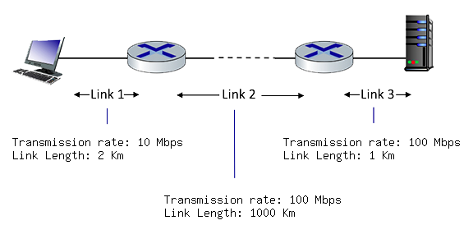
ANS: 0.096 ms
Transmission delay on link 2: 1200*8 bits / 100*10^6 bps = 0.000096 s = 0.096 ms

1.4-04a. Performance: Packet Transmission Delay. Consider the network shown below, with a sending server on the left, sending packets to two different client receivers on the right. The sender is sending packets to the receivers over separate TCP connections. The links have transmission rates of R₁ = 200 Mbps. Assume initially that R₂ = R₃ = 25 Mbps. Suppose each packet is 1 Mbit in size.
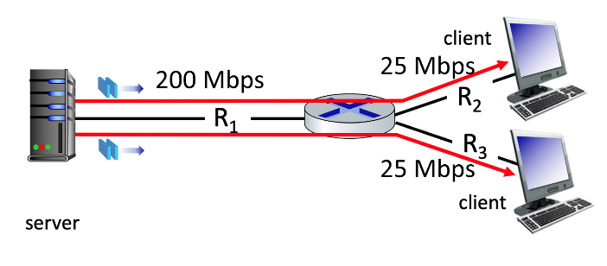
How long does it take a sender to transmit a packet into its link (i.e., the packet transmission delay at the sender)?
ANS: 5 ms

Transmission delay on link with capacity R1: 1*10^6 bits / 200*10^6 bps = 0.005 s = 5 ms

1.4-04b. Performance: End-to-end Delay. Consider again the network shown above. Assume that the propagation delay is 1 msec per link. What is the end-to-end delay of a packet from when it first begins transmission at the sender, until it is received in full by one of the two clients at the right (the answer is the same for both clients)? Assume store-and-forward packet transmission. You can assume the queueing delay and processing delay are both zero.
ANS: 47 ms
Transmission delay on link with capacity R1: 1*10^6 bits / 200*10^6 bps = 0.005 s = 5 ms
Propagation delay on link with capacity R1: 1 ms
Transmission delay on link with capacity R2 or R3: 1*10^6 bits / 25*10^6 bps = 0.04 s = 40 ms
Propagation delay on link with capacity R2: 1 ms
Total = 5+1+40+1=47 ms

1.4-04c. Performance: Maximum Throughput. Consider again the network shown above. Assume that the link with capacity R₁ is fairly shared (as we've seen is done via TCP) between the two sessions. What is the maximum end-to-end throughput achieved by each server-client session, assuming both sessions are sending at the maximum rate possible?
ANS: 25 Mbps

1.4-04d. Performance: Link utilization. Consider again the network shown above. What is the utilization of the link with capacity R1, and the link with capacity R2, assuming the sender is sending packets as fast as possible to both receivers?

ANS: The utilization of the link with capacity R1 is 25 Mbps/200 Mbps =0.125
The utilization of the link with capacity R2 is 25 Mbps/25 Mbps =1.0
1.4-04e. Performance: Maximum Throughput (1). Consider again the network shown above, where R₂ = R₃ = 25 Mbps again. What is the maximum end-to-end throughput achieved by each session, assuming the sender is sending to receivers at the maximum rate possible?
‘ANS: 25 Mbps
1.4-04f. Performance: Maximum Throughput (2). Consider again the network shown above, but now assume that R₂ = 25 Mbps and R₃ = 50 Mbps. What is the maximum end-to-end throughput achieved by each session, assuming the sender is sending to receivers at the maximum rate possible?
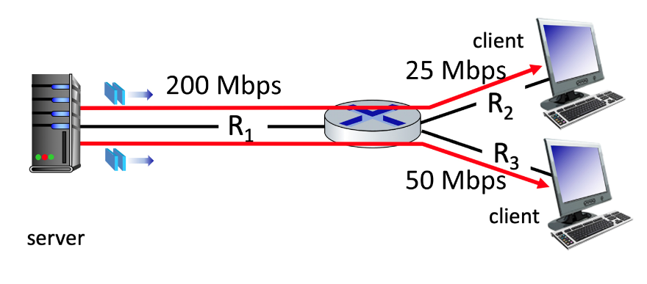
ANS: The TCP session that travels over the link with capacity R2 = 25 Mbps gets 25 Mbps, and the session over the link with capacity R3 = 50 Mbps gets 50 Mbps.

1.4-04g. Performance: Maximum Throughput (3). Consider again the network shown above, with the following link capacities: R1= 10 Mbps, R₂ = 25 Mbps and R₃ = 50 Mbps. What is the maximum end-to-end throughput achieved by each session, assuming the sender is sending to receivers at the maximum rate possible?
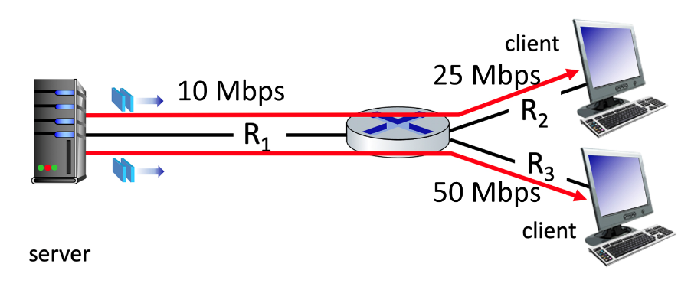
ANS: Each session achieves a maximum throughput of 5 Mbps.
1.4-04h. Performance: Maximum Throughput (4). Consider now the (new!) network shown below, with a new sender (E) sending to D over a new additional TCP session. The links again have transmission rates of R₁ = 100 Mbps (i.e., 100 x 10⁶ bits per second) and R₂ = 150 Mbps. What is the maximum end-to-end throughput achieved by the new E-to-D session, assuming all senders are sending to receivers at the maximum rate possible?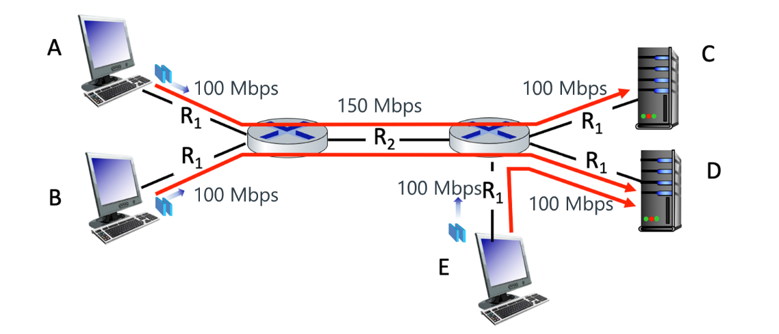
ANS: 50 Mbps. Bottleneck link has bandwidth 100 Mbps, shared between two links.

Chap 3.
Consider the figure below in which a TCP sender and receiver communicate over a connection in which the sender->receiver segments may be lost. The TCP sender sends an initial window of 5 segments. Suppose the initial value of the sender->receiver sequence number is 397 and the first 5 segments each contain 296 bytes. The delay between the sender and receiver is 7 time units, and so the first segment arrives at the receiver at t=8. As shown in the figure below, 2 of the 5 segment(s) are lost between the segment and receiver.
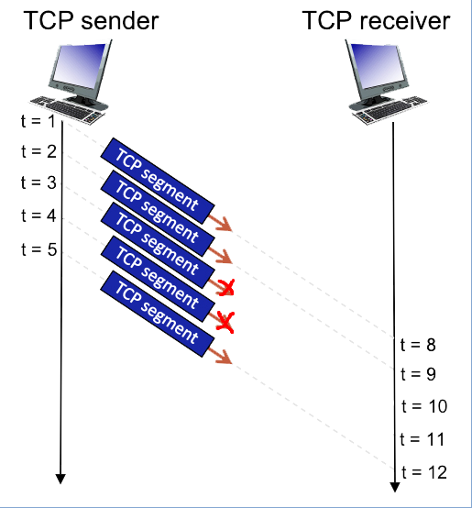

a) Give the sequence numbers associated with each of the 5 segments sent by the sender. Format your answer as: a,b,c,... (Hint: Sequence numbers are equal to the sum of the previous bytes sent and the old sequence number)
ANS: 397,693,989,1285,1581

b) Give the ACK numbers the receiver sends in response to each of the segments. If a segment never arrives use 'x' to denote it, and format your answer as: a,b,c,... (Hint: ACKs cumulatively add the bytes received to the sequence number.)
ANS: 693,989,x,x, 989

Chap 4.
Consider the pattern of red and green packet arrivals to a router’s output port queue, shown below. Suppose each packet takes one time slot to be transmitted, and can only begin transmission at the beginning of a time slot after its arrival. Give your answer as 7 ordered digits (each corresponding to the packet number of a departing packet), with a single space between each digit, and no spaces before the first or after the last digit, e.g., in a form like 7 6 5 4 3 2 1.
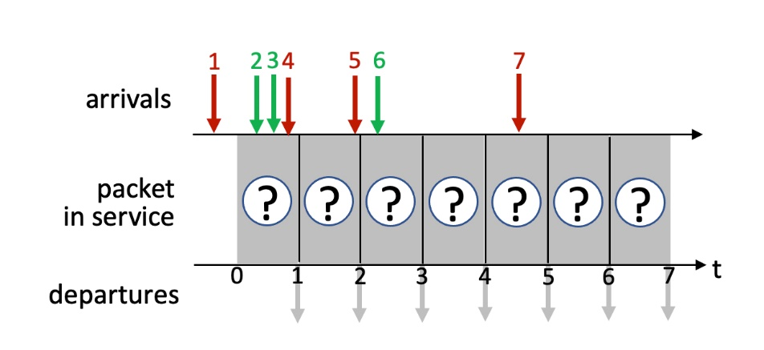
a) Indicate the sequence of departing packet numbers (at t = 1, 2, 3, 4, 5, 7, 8) under FCFS scheduling.
ANS: 1 2 3 4 5 6 7

b) Indicate the sequence of departing packet numbers (at t = 1, 2, 3, 4, 5, 7, 8) under priority scheduling, where red packets have higher priority.
ANS: 1 4 5 2 3 7 6

c) Indicate the sequence of departing packet numbers (at t = 1, 2, 3, 4, 5, 7, 8) under round robin scheduling, where red starts a round if there are both red and green packets ready to transmit after an empty slot.
ANS: 1 2 4 3 5 6 7

Chap 4.

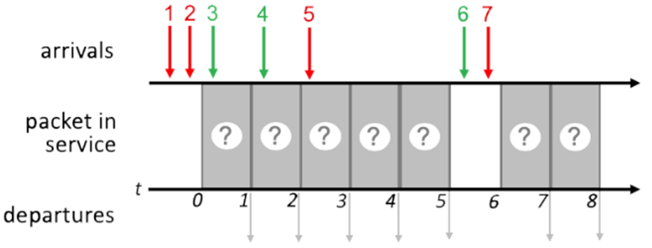
a) Indicate the sequence of departing packet numbers (at t = 1, 2, 3, 4, 5, 7, 8) under FCFS scheduling.
ANS: 1 2 3 4 5 6 7

b) Indicate the sequence of departing packet numbers (at t = 1, 2, 3, 4, 5, 7, 8) under priority scheduling, where red packets have higher priority.
ANS: 1 2 3 5 4 7 6

c) Indicate the sequence of departing packet numbers (at t = 1, 2, 3, 4, 5, 7, 8) under round robin scheduling, where red starts a round if there are both red and green packets ready to transmit after an empty slot.
ANS: 1 3 2 4 5 7 6

Chap 4. Subnetting.
a) What is the maximum # of interfaces in the 223.1.2/25 network?
b) What is the maximum # of interfaces in the 223.1.3/28 network?
Including the network address (all host bits in the IP address equal to 0) and broadcast address (all host bits in the IP address equal to 1).
c) Which of the following addresses can NOT be used by an interface in the 223.1.3/28 network? Check all that apply.
223.1.3.6, 223.1.3.2, 223.1.3.16, 223.1.2.6, 223.1.3.28
d) How many bits in the host address are needed to be able to address all of the host in a subnet with 200 hosts?

ANS:
a) In 223.1.2/25 Network, since 32-25=7 bits for host address, hence maximum # of Interfaces = 2^7=128
b) In 223.1.3/28 Network, since 32-28=4 bits for host address, hence maximum # of Interfaces = 2^4=16
c) In 223.1.3/28 Network, since 32-28=4 bits for host address, hence maximum # of Interfaces = 2^4=16, ranging from 0 to 15. Hence
223.1.3.6, 223.1.3.2 are OK
223.1.3.16, 223.1.3.28 are not OK since the host ID exceeds 15
223.1.2.6 is not OK since network address 223.1.2 does not match 223.1.3
d) 8, since 2^7=128, so 7 bits is not enough to address 200 hosts. 2^8=256, so 8 bits is enough to address 200 hosts.

Chap. 5.0. Consider the following ujdirected graph. Use Dijkstra’s algorithm to find shortest paths starting from source vertex 1. SD: Shortest Distance. PN: Previous Node
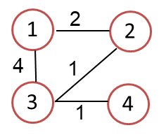

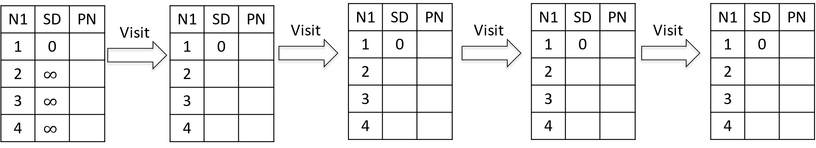
ANS:
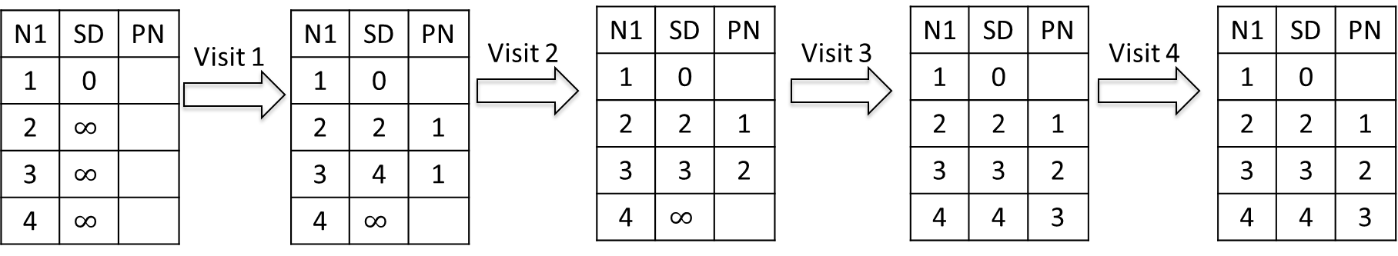

Chap. 5.0. Consider the following directed graph. Use Dijkstra’s algorithm to find shortest paths starting from source vertex 1. SD: Shortest Distance. PN: Previous Node
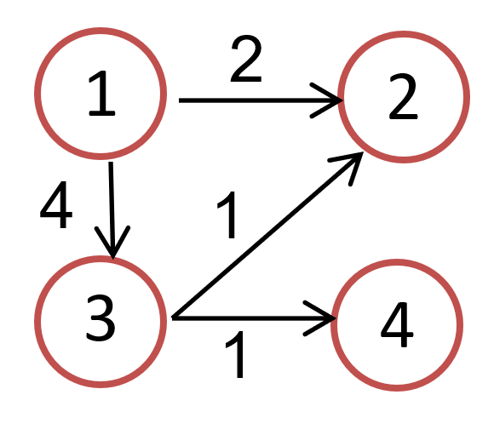


ANS:
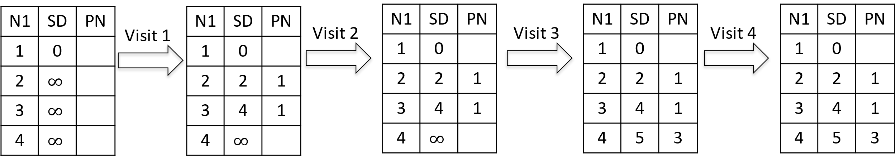

Chap 6.1 6.2
Consider multiple parity bits for a two-dimensional array of data bits: Transmit data as a block of i rows of j bits per row and add parity bit to each row and each column. For i rows and j columns, compute j column parity bits (last row), i row bits (last column), and one corner parity bit computed by the row and column parity bits. Suppose i=j=4, and the error-free data block and the parity bits are shown below.
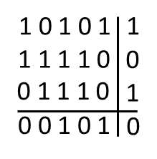
Consider the following bit error patterns. Give the number of row parity errors, column parity errors, and corner parity errors.
a)
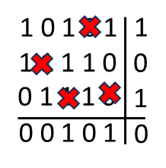
ANS: 4-bit error causes
_2_row parity errors
_4_column parity errors
_0_corner parity errors

b)
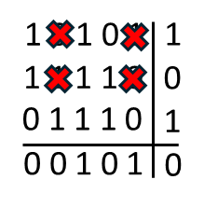
ANS: 4-bit error causes
_0_row parity errors
_0_column parity errors
_0_corner parity errors

Chap. 6.1 6.2
Suppose that a packet 1001 1100 1010 0011 is transmitted using Internet checksum (N=4-bit integer). What is the value of the checksum? Show your calculation process.
ANS: One’s complement sum for 4-bit integers is defined as sum modulo 2N, N=4, and adding any overflow of high order bits back into low-order bits, then taking one’s complement.
0011+1010 = 1101
1101+1100 = 1001+1 = 1010
1010+1001 = 0011+1 = 0100.
So, the Internet checksum is 1011, the one’s complement of 0100.
You can also do it in one step as shown below. (This can be cumbersome if the numbers are large and you have large carries at each step, so adding each number one step at a time may be easier.) 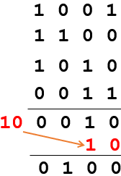

Chap. 6.1 6.2
A bit stream 1001 is transmitted using the standard CRC method. The generator is 1011. Show the actual bit string transmitted. Show the modulo 2 division process.
ANS: D=1001, G=1011, r=3. Compute R
The message after appending three zeros is 1001000. The remainder on dividing 1001000 by 1011 is 110. So, the actual bits transmitted are 1001110.
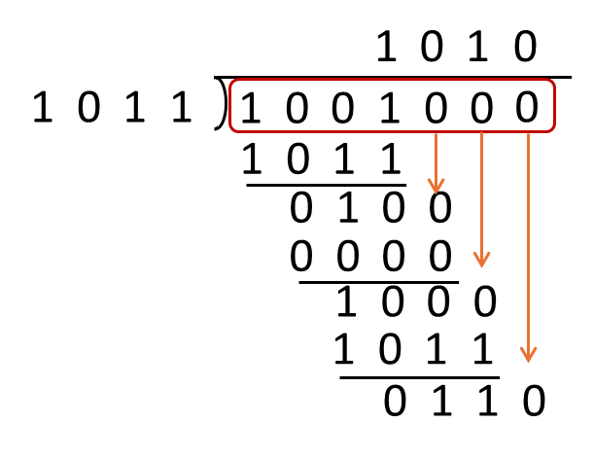

Chap 7.1
Q1: Consider the codes for two senders: Sender 1 Code: (1,-1,-1,-1,1,-1,-1,-1), Sender 2 Code: (1,-1,1,-1,1,-1,1,-1). Are they orthogonal?
ANS: Inner product (1,-1,-1,-1,1,-1,-1,-1) ⋅ (1,-1,1,-1,1,-1,1,-1) = 4, so not orthogonal

Q2: Consider the codes for two senders: Sender 1 Code: (1,-1,1,-1,1,-1,-1,-1), Sender 2 Code: (1,1,1,1,1,1,1,-1). Are they orthogonal?
ANS: inner product (1,-1,1,-1,1,-1,-1,-1)⋅ (1,1,1,1,1,1,1,-1) = 0, so they are orthogonal

Q3: With the codes in Q2, suppose Sender 1 sends data bit 1 and Sender 2 sends data bit -1 simultaneously, compute the encoded data.
ANS: 1* (1,-1,1,-1,1,-1,-1,-1) + (-1)* (1,1,1,1,1,1,1,-1)=(0,-2,0,-2,0,-2,-2,0)

Q4: Compute the decoded data bit for Sender 1 and decoded data bit Sender 2.
A: Decoded bit for Sender 1: (1/8)*(0,-2,0,-2,0,-2,-2,0)⋅(1,-1,1,-1,1,-1,-1,-1) = 1
Decoded bit for Sender 2: (1/8)*(0,-2,0,-2,0,-2,-2,0)⋅(1,1,1,1,1,1,1,-1) = -1

Chap 7.1
A CDMA receiver receives the following encoded data:
(-1 +1 -3 +1 -1 -3 +1 +1).
Assuming the following codes used by four sending stations (they are pairwise orthogonal to each other),
A=(-1,-1,-1,+1,+1,-1,+1,+1)
B=(-1,-1,+1,-1,+1,+1,+1,-1)
C=(-1,+1,-1,+1,+1,+1,-1,-1)
D=(-1,+1,-1,-1,-1,-1,+1,-1)
which stations transmitted, and which bits did each one send?
A: Compute the normalized inner products with each code:
A’s data:(1/8)*(-1 +1 -3 +1 -1 -3 +1 +1) ⋅ (-1,-1,-1,+1,+1,-1,+1,+1) = 1
B’s data:(1/8)*(-1 +1 -3 +1 -1 -3 +1 +1) ⋅ (-1-1+1-1+1+1+1-1) =-1
C’s data:(1/8)*(-1 +1 -3 +1 -1 -3 +1 +1) ⋅ (-1+1-1+1+1+1-1-1) =0
D’s data:(1/8)* (-1 +1 -3 +1 -1 -3 +1 +1) ⋅ (-1-1-1-1-1-1-1-1) = 1
Stations A, B, and D transmitted bits 1, -1, 1 respectively while station C did not transmit.
(Transmitted bits 1, -1, 1 correspond to application bits 1, 0, 1.)

Chap 8.1 Consider the 3-bit block cipher in the Table below.
Plain | 000 | 001 | 010 | 011 | 100 | 101 | 110 | 111
Cipher | 110 | 111 | 101 | 100 | 011 | 010 | 000 | 001
Suppose the plaintext is 100101100. Suppose that Cipher Block Chaining (CBC) is used with Initialization Vector (IV)=111. What is the resulting ciphertext? Show you calculation process.
ANS: (You do not need to write too much text explanations, but only need to write out the formulas for each intermediate step.)
The first step is to XOR the first plaintext block with IV = 111
First plaintext block: 100, so 100⊕111=011
Now we encrypt this result (011) using our cipher table: 011 maps to 100.
Second Block: Now we XOR the second plaintext block with the first ciphertext block:
Second plaintext block: 101, so 101⊕100=001
Now we encrypt this result (001) using our cipher table: 001 maps to 111.
Third Block: Finally, we XOR the third plaintext block with the second ciphertext block:
Third plaintext block: 100, so 100⊕111=011
Now we encrypt this result (011) using our cipher table: 011 maps to 100.
Resulting ciphertext for plaintext 100101100 is 100111100.

Chap. 8.1. Suppose Alice and Bob wish to do Diffie-Hellman key exchange. Alice and Bob have agreed upon a prime p = 13, and a generator g = 2. Alice has chosen her secret number (private exponent) to be a = 5, while Bob has chosen his private exponent to be b = 4.
Show the intermediate quantities that both Alice and Bob calculate, as well as the final (shared) secret that Diffie-Hellman produces.

ANS:
Alice sends to Bob: $A=g^{a} mod p=$2^5 mod 13 = 6.
Bob computes the secret: $S=A^{b} mod p$ = 6^4 mod 13 = 1296 mod 13 = 9.
Bob sends to Alice $B=g^{b} mod p$= 2^4 mod 13 = 3.
Alice computes the secret: $S=B^{a} mod p$ = 3^5 mod 13 = 243 mod 13 = 9.

